Historical Battle Simulator
Manual

Welcome to the Historical Battle Simulator! We hope you are as excited as we are about getting a chance to step into the shoes of some of the greatest generals and admirals! Will you recreate battles in historical order? Or will you play as the Napoleon who wins at Waterloo? The choice will be yours!

I. Playing The Game
This section is intended for students
Choosing A Scenario

The first thing you will notice when you click is a folder displaying a variety of different scenarios. Each of these scenarios have either been created by your instructor, or by our production team. Either way, the titles should be fairly self-explanatory (e.g. Agincourt1415.txt, Waterloo.txt).

Once you select the campaign that you are going to play, the game will set you against your classmate and the two of you will get a chance to battle!

Display
Therefore, chances are you are currently looking at a field that looks something like this:
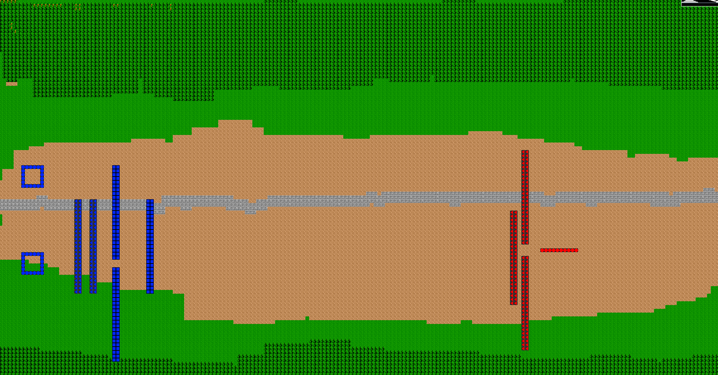
As you may have guessed, this is the recreation of the scenario! However, you may understandably be having difficulty understanding what is going on.

Icons and Symbols

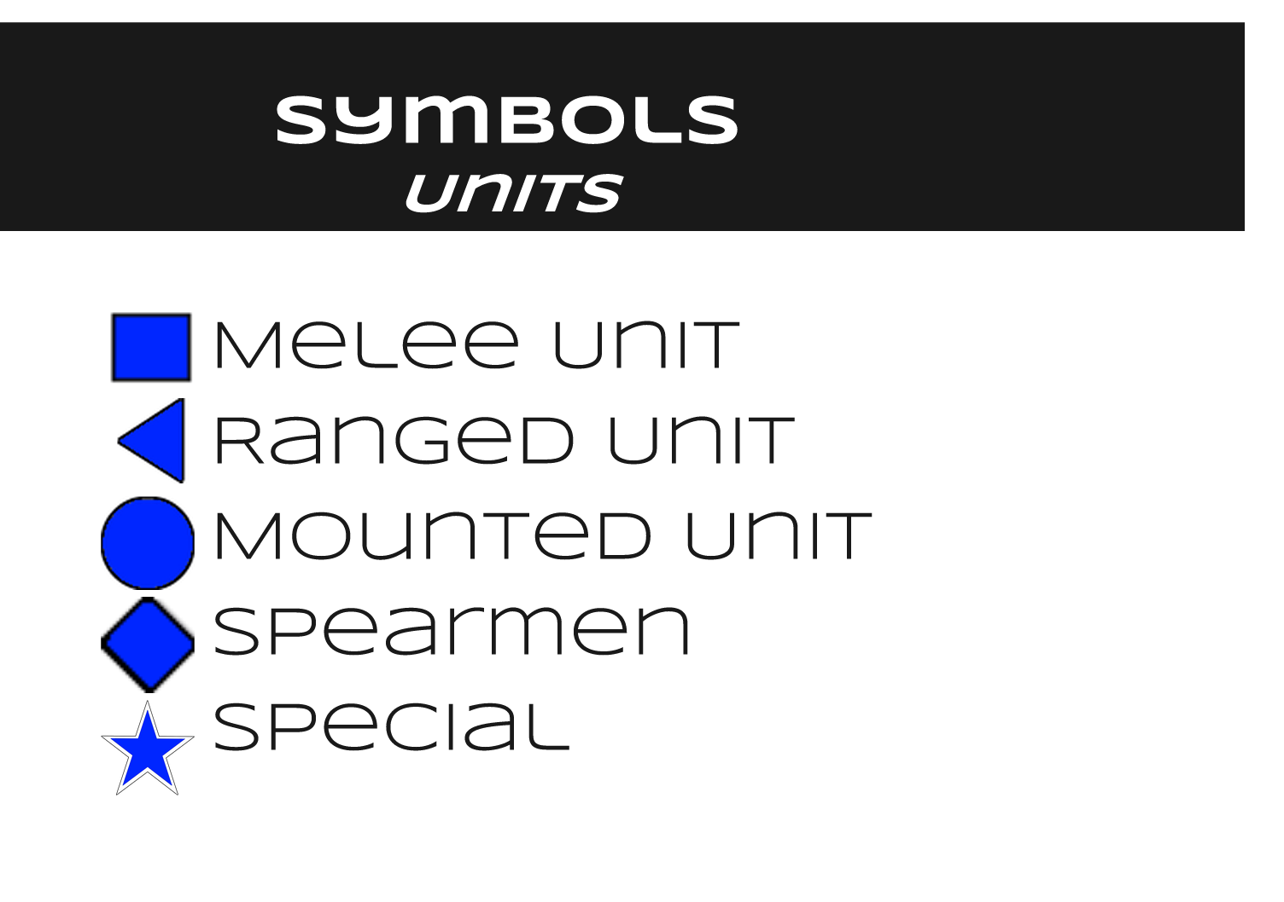
The icons displayed above give a good idea of what exactly each of these symbols mean. But what are these exactly?
Melee: Melee is someone who fights in hand to hand combat! The quintessential tough guy of warfare, they come in all shapes and sizes.
Ranged: Typically wielding a bow, gun, or javelins, the ranged class prefers to attack from a distance, relying on their accuracy.
Mounted: These are units on horses, cars or anything of the like. They move much faster than units that are walking and are a dangerous force on the battlefield.
Spearmen: These are those who wield spears! A long pointy stick may sound crude, but for thousands of years they dominated the battlefield.
Special: Some units don’t fit into the aforementioned types. This may be a general, a siege engine operator, or someone who doesn’t fit into the other classification.

Although units can be colored one of many colors, but these symbols are used to represent units throughout the whole game. All other symbols represents terrain features. For example, green is grass, brown is dirt, trees represent trees and blue is water.

Turns
Each time you take a turn, all of your units’ ‘unit points’ (the amount of actions they get to execute) will be reset to two. This means you can do two of the things that appear on the menu when you select a unit. This will generate the following:
Each of these buttons has a crucial role to play in the battle.

Attack: Opens a menu including all of the units with in the selected unit’s range. That is to say, everyone that they can hit! Opening this up brings you into combat.

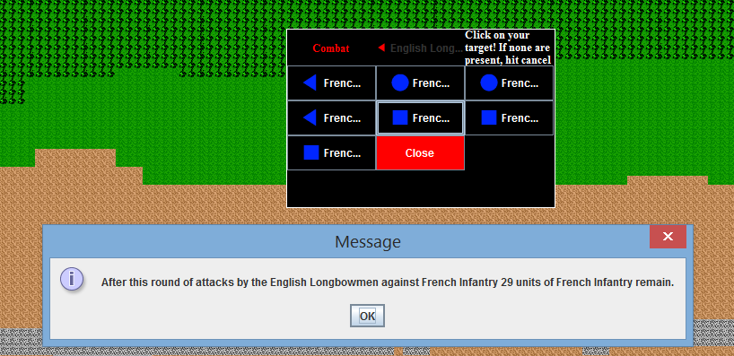
Defend: This causes a unit to brace themselves, put up their shields if they have them. It gives them a bonus against any attack on them.

Check Stats: Gives you the numbers on what the selected unit’s statistics are.

Move: Opens the following panel to allow you to guide a unit for their selected amount of tiles. This amount is stored in the ‘Speed’ value of a unit.

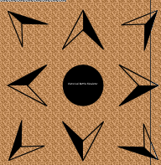
Note: Sprinting can be done by selecting the button in the middle! This allows your units to move twice as far in a turn, but will use up their stamina the more you do it.

Set Formation: This opens up a menu and allows you to choose what formation you want your troops to be in. Prior to the invention of automatic weapons, formations dominated warfare! Disciplined soldiers who could hold formation were the most valuable and were very effective on the battlefield! A unit that stood together and charged would cause a lot more damage than a loosely dispersed group for instance, and a unit that held a square would be able to fight off a cavalry charge more effectively.

For our uses, we have the following formations available:
Column: This formation exposes just the front to the opposing army. It is good for approaching through a small pass.
xx
xx
xx
xx
xx
xx

Row: This formation exposes the broad face to the opposing army. It has the most ‘surface area’ exposed to the enemy.
e.g.
xxxxxxxxxxxxxxxxxxxxxxxxxxxxx
xxxxxxxxxxxxxxxxxxxxxxxxxxxxx

Square: This formation is, as you may have guessed, a square. It is the best defensive formation and used to hold a position and defend it from both sides. It is particularly good against cavalry.
e.g.
xxxxxxxxxxxxxx
xx xx
xx xx
xx xx
xxxxxxxxxxxxxx

Cancel Selection: This button exits you out of the selection method and allows you to select another unit.

II. Creating Units
This section is intended for instructors.

To create a unit, select the button. This will open up the menu and allow you to fill in the data. All of the data values are explained in the following document.

The following document is meant to explain the different components of a unit, and the statistics associated with them.
Unit Name:
The name of the selected unit. This name should refer to its general name. It can also include adjectives such as country or region names to denote what sort of unit it is.
E.g.: Cretan Archers, Longbowmen, Spartan Hoplites, General’s Bodyguard
Unit Type:
The type of unit being referred to. This is denoted as an integer between 1-5. The values are as follows.
1: Melee : Melee units fight in hand to hand combat. They wield weapons such as shields, swords, knives, axes and the like as their primary weapons.
E.g.: Roman Leggionares, Germanic Berserker, Dismounted Knight
2: Ranged: Ranged units fight from a distance. They wield weapons such as bows, arrows, sling and guns. They typically attempt to keep their distance from their opponents at all costs, as they are typically weaker in direct combat. Siege weapons fall under this category, although they are typically slow moving.
E.g.: Cretan Archers, Longbowmen, Velites, Slingers, Ballista
3: Cavalry: Mounted melee units. These units are fast moving, and typically get a bonus to charge as a result of their bonus. They are especially effective against ranged units because of the ranged units typically lower armor.
E.g.: Roman Auxiliary Cavalry, Heavy Cavalry, Light Cavalry
4: Spearmen: Melee units that wield long pikes of some sort. These units are exceptional at defense typically, and can damage cavalry very effectively by using formations such as ‘pike walls’ and ‘phalanax formation’. These units are most effective in tight formation. However, they move slower and may make easy targets for siege weapons or archers.
E.g.: Spartan Hoplites, Colonial Militia Pikeman, Barbarian Pikeman
5: Special: Units that do not fit into the traditional schema laid out above. This may include units that are hybrids of the others.
Attack(ATK):
This value refers to the bonus that is given to the soldiers chance of hitting their opponent. It is a bonus meant to be added to a randomly generated integer between 1-20, which compares against the units defense. It is a product of the soldiers expertise and training. For instance, a very precise marksmen would have a high bonus, while a clumsy one would not. A basic way of understanding the bonuses is visible in this table.

Value | Examples
-5 | The efficiency of wielding a sword with your bad hand after breaking both your arms.
-4 | A very clumsy wielder, perhaps a child who has picked up his fathers sword
-3 | Unlikely to hit anyone except the worst defended people.
-2 | A dazed warrior, or a novice person attempting to use a weapon they I’ve never used. An untrained peasant might have this  bonus
-1 | A slightly below average warrior
0 | Average
1 | A slightly experienced soldier, perhaps a militia trained swordsman
2 | A regular of an army would likely have this bonus
3 | An attack focused unit, such as a longbowmen might have this bonus
4 | The most elite forces of an army may have this bonus
5 | The best of the best

Damage (DMG):
This number refers to the range of which a unit can do damage. In a tabletop game this would
refer to the amount and type of dice that would be rolled to determine the damage dealt. The damage dealt will be subtracted directly from the HP of the opponent. This is based mainly on the type of weapon. For
brevity’s sake, ‘dice’ refers to the range of numbers that the damage is randomly generated from.

Dice | Weapons
1 to 4 | Hand to hand combat, slings, thrown rocks and daggers, small daggers, shuriken
1 to 6 | Short swords(Roman Gladius), short bows, one handed axes1
1 to 8 | Javelins, one handed spears, long bows, basterd swords
1 to 10 | Two handed swords, two handed axes, crossbows
1 to 12 | Muskets, basic rifles
1 to 18 | Ballista shooting flaming bolts, cannonballs

Damage Bonus:
This number refers to the bonus applied to the characters damage if they get a ‘hit’. It is based on components such as the specific make of the weapon they use, or the training and strength. A barbarian axe wielder for example may get a very large bonus here, although there clumsy style may make it harder
for them to hit another unit.

Value | Examples
-5 | A very weak man attempt to hit something with a very flimsy sword
-4 | A weak person or weapon
-3 | The weapon is very damaged
-2 | A weapon that is damaged, or that the person wielding it does not know how to use.-
-1 | A slightly below average warrior
0 | Average
1 | A milita of the army may have this bonus, if they are equipped with average weapons
2 | A regular of an army would likely have this bonus, if equipped sufficiently.
3 | An attack focused unit, such as a longbowmen might have this bonus
4 | An damage focused unit, such as a berserker might have this bonus, if equipped  sufficiently.
5 | The best of the best at doing damage, with the best weapon.

Hit Points(HP):
The amount of health an average character has. This value decreases when the unit takes damage. It is based on the strength and health of the individual person, but on average units usually have approximately 10 health. Since the average weapon does around 6-12 damage, units who sustain any amount of direct hits are likely to be reduced to wounded(a condition that occurs at half health and has negative bonuses on all actions) and killed much quicker. The average values for the main unit types are
as follows:

Value | Type
15 | Spearmen
12 | Cavalry
10 | Melee
7 | Ranged
5 | Peasant

Armor Class(AC):
This refers to the overall defensive value, or ‘armor class’ of a unit. It is the number that the attacker is attempting to ‘beat’ when they attack. It is a constant value, which gets a bonus based on if the unit is ‘defending’ or in defensible terrain. This is a mixed value, so one unit may have a high AC based on there heavy armor, while another might have one because of their speed and agility making them hard to hit.

Value | Examples
1-5 | A prone and vulnerable target.
6 | Children, peasants, etc.
7 | Armed peasant, no armor
8 | Levy spearmen, levy javelin bearer, no armor.
9 | Militia(cloth wearing)
10 | Armored militia (Some leather), Velite, Bowmen
11 | Gallic warrior(leather armored)
12 | Persian mercenrary (Some chainmail, some leather)
13 | Crossbowman (all chain mail), Pikeman
14 | Roman soldier (Some chain mail and plate, shield wielding)
15 | Hoplite, knight(mostly plate, a shield)
16 | Full plated knight
17 | Specialty plate
18 | Scalemail
19 | Modern body armor
20 | Batman
Defense:
This value is a bonus added when a unit is ‘defending’. It gives the unit a higher AC when they get attacked, if they have selected to defend. Units have a much higher defense value if they posses shields.

Value | Type
1 | Average (no shield)
2 | Buckler
3 | Kite shield
4 | Square shield
5 | Hoplite Shield

Speed: The amount of tiles that a unit can move in a turn. Each tile represents a 5 by 5 foot square. This is the amount of ground that a unit can cover in 5 seconds. The average speed is 5 squares. When a unit sprints, they expend a stamina point and double their speed for the turn.

Speed | Example
1 | Trebuchet
2 | Ballista, scorpion, injured soldier, pikeman in formation
3 | Soldier in heavy armor, mobile pikeman
4 | Soldier in chain or leather
5 | Lightly armored soldier
6 | A scout or archer or heavy armored soldier
7 | An injured mounted unit
8 | A sprinting soldier in medium armor
10 | A sprinting lightly armored soldier. Slow mounted unit(Elephant)
12 | Average mounted unit, sprinting socut
14 | Fast mounted unit(light cavalry)
20 | Sprinting slow mounted unit
24 | Sprinting average mounted unit
28 | Sprinting fast mounted unit

Range: This value is the range of which a unit can attack. For melee units, this value is 1, referring to the amount of squares they can reach. For spearmen the value is 1.5 squares, insinuating that they can strike slightly further. For ranged units, this value depends on their weapons and personal training. Some examples are provided below.

Range | Example
1 | Average Melee
1.5 | Spearmen
3 | Javelin(most thrown weapons)
6 | Slings, shortbows
8 | Average bow, musket
10 | Longbow, Ballista
15 | Modern rifle
20 | Trebuchet
25 | Sniper rifle

Charge Bonus:
This value refers to the bonus applied to a unit’s damage when charging. For all units, charging gives them some bonus, but the larger and thus more inertia a unit has, the higher the charge bonus. Heavy cavalry units typically have the highest charge bonuses (elephants and tanks being the maximum).

Value | Example
1 | Ranged Unit, peasants
2 | Basic melee unit (basic armored foot soldier), Pikeman
3 | Heavily armored foot soldier
4 | Berserkers, shock troops
5 | Light cavalry
7 | Regular Cavalry
10 | Heavy Cavalry
15 | Elephants or tanks
Stamina:
This value refers to the amount of stamina a unit has. The more armor a unit is wearing, or the less they are physically conditioned, the less they are able to sprint. The average value, for a medium armored unit is 2. Some units may have higher stamina based on their individual training. This is up to the character designer’s discretion.

Value | Example
1 | Full plate, heavy chain mail
2 | Medium armor
3 | No armor or exceptionally trained units in medium
4 | Specially trained scouts
5 | Chuck Norris

III. Map Creator
This section is intended for the instructor.

In order to create a map, click the button. This will generate the following interface.
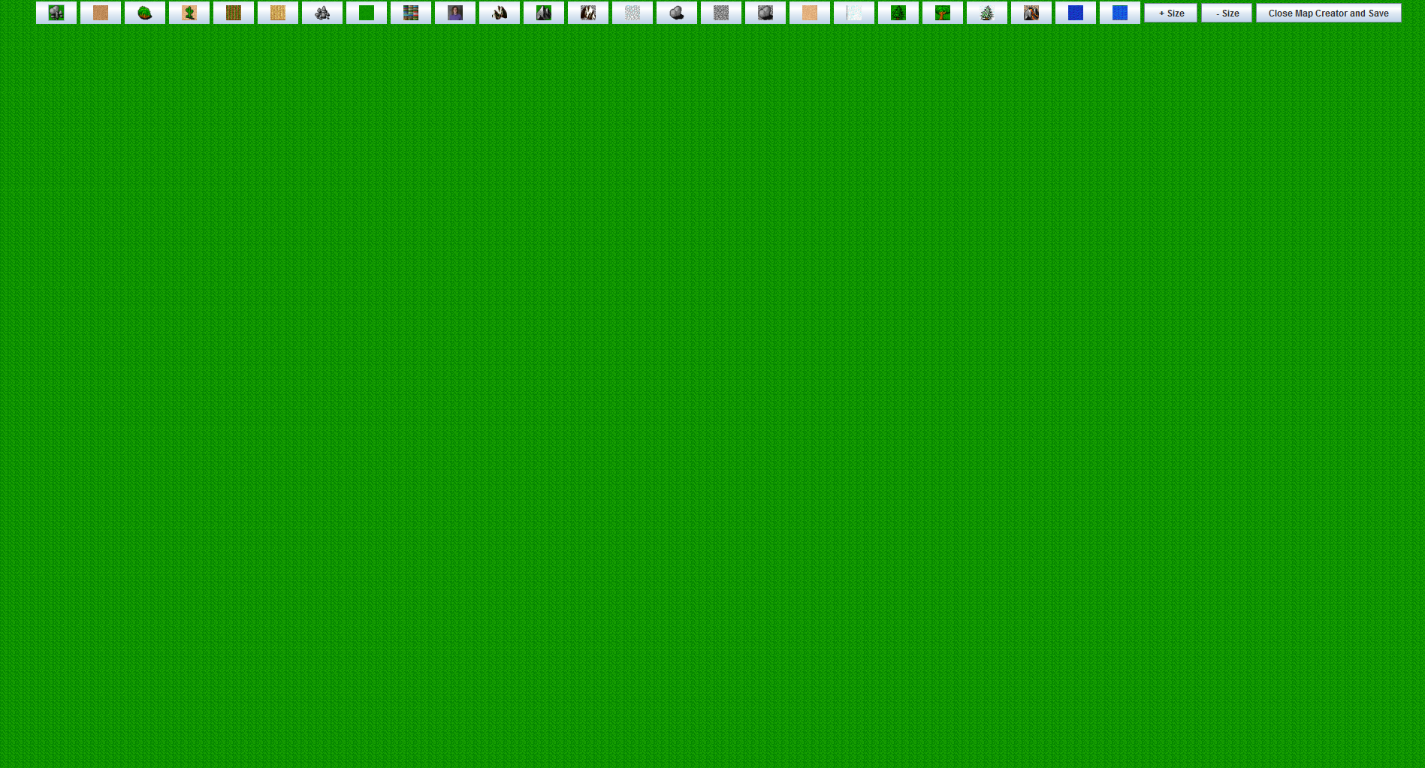
You can add terrain by clicking any of the buttons on the top:
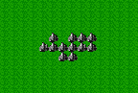
After you select this, you can click the place on the field where you wish to place the terrain.
You can also increase or decrease the size of the terrain you are placing by selecting the +Size and -Size Buttons.

When you are done, click the [Close Map Creator and Save] and write a name to save the file as.

IV. Scenario Creator
This section is intended for the instructor.
The scenario creator allows for the placement of the units that have been created on the field.

First select a Map:
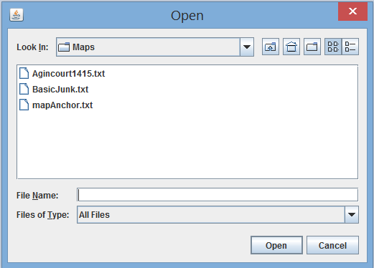
Than name each Army:
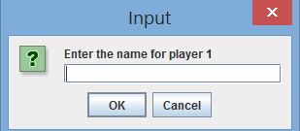
Select a List of Units:
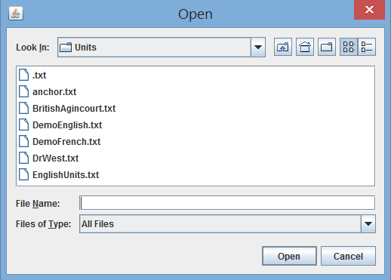
Than place them on the field of battle!
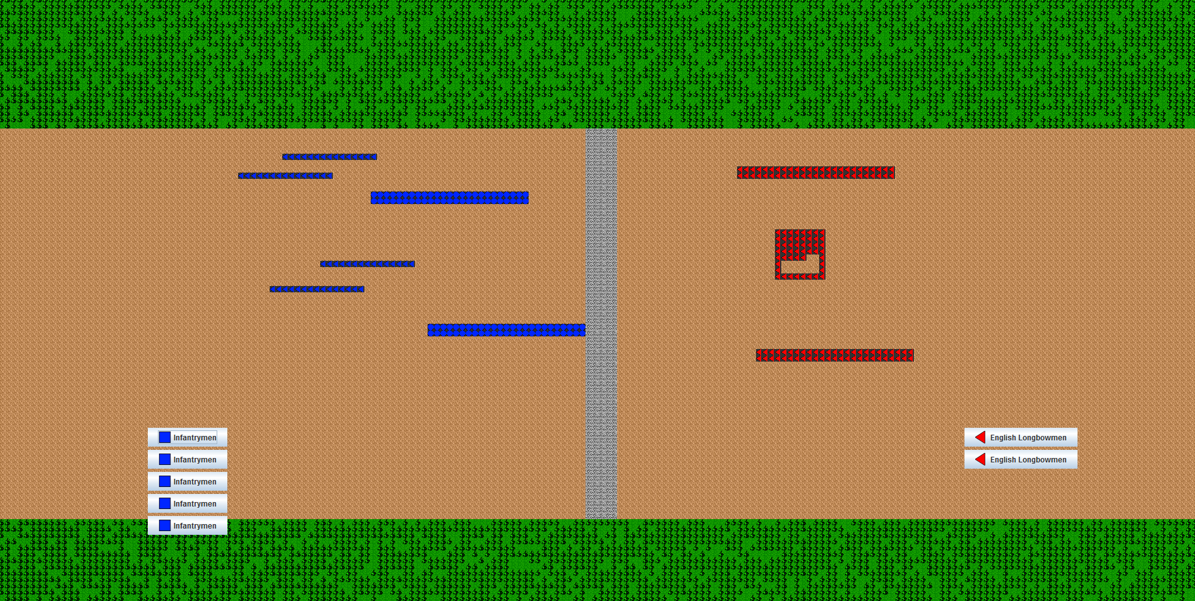

Conclusion

Good luck instructors and players! We hope that you enjoy this game as much as we enjoyed making it!

